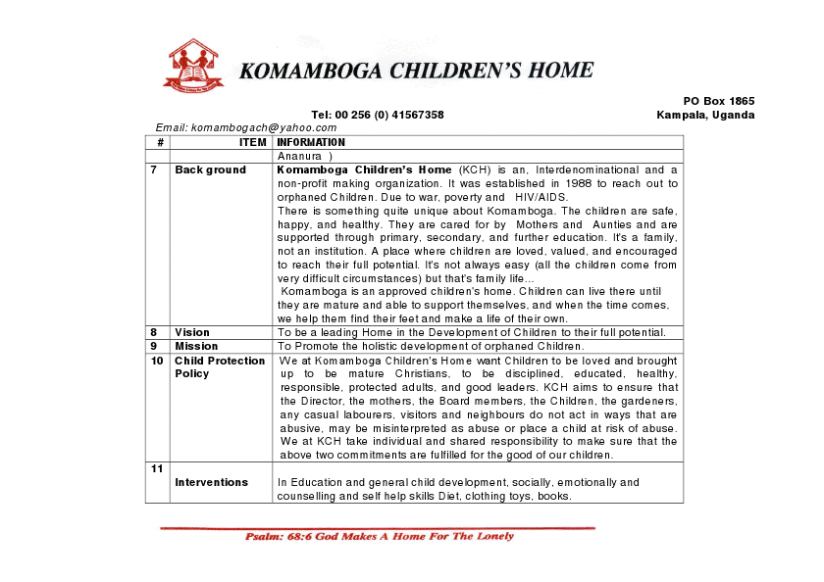
FAITH CHILDRENS CENTRE,KATOOKE
P.O.BOX5090,KAMPALA-UGANDA
Tel:+256782461200
Email:deliveranceworldmission@gmail.com
http://deliveranceworldmission.yolasite.com/
www.dwm.cfsites.org

Faith children’s centre is an Interdenominational and a non-profit making organization. It was established in 2006 to reach out to orphaned children. to war, poverty and HIV/AIDS.
There’s something quite unique about Faith children’s centre. The children are safe.
Happy .and healthy. They are cared for well by Teachers. And are supported through primary secondary and future education. It’s a fhttp://deliveranceworldmission.yolasite.com/amily not an institution a place where children are loved. Valued and encouraged to reach their full potential. Its not always easy (all children come from very difficult circumstances) but that is a family life. Faith Children centre is an approved centre for children.
Children can live there until they are mature and able to support themselves. And when the time comes we help them find their fit and make a life of their own
Vision: To be a leading centre in the development of children to their full potential
Mission: To promote the holistic development of orphaned children.
Child protection policy: we at faith children’s centre want children to be loved and brought up to be mature Christians to be displined .educated .healthy and responsible people and leaders of the future.FCC. Aims to ensure that the Director, Teachers and Board members and all the workers, do not act in any ways of abusive. May be a place a child at risk we at FCC take individual and shared responsibilities to make sure that the two above comments are fulfilled for the good of our children.
NEEDS in child Education and general development, socially emotionally and counseling and self help skills Diet, clothings toys, books, shoes

